Wubshet Assefa Tessema, M.D.
wubossassefa@yahoo.com.
Wubshet_assefa@dmu.edu.et
Twitter & Instagram: @Wubshet Assefa
Facebook: http://www.facebook.com/wubshet.assefa.3
ORCID: https://orcid.org/0000-0002-5428-1624
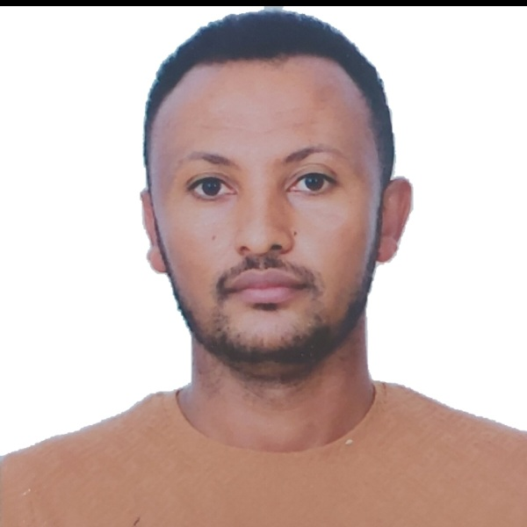

CURRICULUM VITAE

- EDUCATION
- 11/2007 – 12/2013 Doctor of Medicine (MD)
  - Haramaya University, Ethiopia

- POST-GRADUATE TRAINING
- 03/2015 – 02/2018 Specialization, Anatomic Pathology (AP)
  - Jimma University, Ethiopia

- ACADEMIC & PROFESSIONAL APPOINTMENTS
- 1/2014 -03/2015 ; Lecturer, Health science college
    - Adigrat University
- 03 /2018 - 4/2019 ; Assistant Professor, Pathology Unit
    - Adigrat University
- 5/2017 –7/2023 ; Assistant Professor, Head of Pathology Department
    - Debre Markos University
- 7/2023-Present; Assistant professor , Chief anatomic pathologist
    - Bahir dar University

- Membership in Professional Organizations
- Ethiopia Pathology Society (EPS)
  - Founding Member
  - Executive council member
  - Director of research and publication
- College of American Pathologists International Fellow Member
- Ethiopia Medical Association (EMA)
  - Active Member

- PRACTICAL PATHOLOGY EXPERIANCE
- 03/2015 – Present
- Initiating and providing routine facility based anatomic pathology services
- Performing and interpreting FNAC and studying cytopathology slides including effusion cyotology .
- Working in histopathology Unit; grossing of biopsy specimens and Microscopic examination of tissue sections with special interest in Gynecologic pathology and Oncopathology
- Working in Hematopathology: analysing peripheral blood films, bone marrow aspirates and trephine biopsies
- Working in autopsy section with knowledge of grossing autopsy specimen and studying tissue sections

- RESEARCH ACTIVITIES AND PUBLICATIONS:
(ORCID: https://orcid.org/0000-0002-5428-1624 )

- Clinico-epidemiologic Considerations in the Diagnosis of Tuberculous Lymphadenitis: Evidence from a high burden country DOI: 10.1016/j.ijid.2022.09.030
- A glimpse at locally advanced melanomas in the settings of
poverty: pathologists viewpoint DOI 10.1097/CMR.0000000000000909
- Chromoblastomycosis: delayed diagnosis with extensive cutaneous
lesions DOI : 10.1016/j.ijid.2023.03.040
- Sub-chronic toxicity of the aqueous leaf extract of Ocimum lamiifolium Hochst. ex Benth on biochemical parameters and histopathology of liver and kidney in rats: in vivo and in- silico toxicity studies. DOI: 10.1186/s12906-023-03863-7
- Early onset, delayed diagnosis and laterality of breast carcinoma: Evidence from a tertiary care hospital DOI 10.1177/20503121221114623
- COVID-19 Vaccine: Side Effects After the First Dose of the Oxford AstraZeneca Vaccine Among Health Professionals in Low-Income Country: Ethiopia DOI: 10.2147/jmdh.s331140
- Breast hydatid cyst presented as a fluctuant painless lump mimicking galactocele: A case report DOI: 10.1016/j.ijid.2022.11.004
- Recurrent Intahepatic Cholestasis of Pregnancy with History of Fetal Demise DOI:10.2147/IMCRJ.S416955
  - Giant biliary mucinous cystadenoma mimicking mesenchymal hamartoma of the liver in a child: A case report DOI 10.1016%2Fj.ijscr.2021.106523
  - Presence of Mycobacterium and Other bacteria in lymph-
denopathies with purulent Aspirates, Jimma university Specialized hospital Ethiopia” DOI 10.21767/2472-1093-C1-003
- A rare presentation of Ludwig's angina with facial nerve palsy, case report
DOI: 10.1016/j.ijscr.2023.108309

- COMPETENCIES
- Relevant Computer skills: Experienced with IBM, SPSS, ,STATA and microsoft office
- Language skills : Amharic and English (Excellent in reading, writing and speaking)

- PROFESSIONAL TRAININGS
- Instructional designing skill
- Fundamentals of Leadership
- Systematic review and meta-analysis
- Basic HIV and ART training
- Attended the first, second and third annual conferences of Ethiopian society of pathology
- Attended annual meeting of College of American Pathologists 2023

- GUEST QUALIFICATION EXAMINER EXPERIENCE

- External Examiner for PC II medical students at Jimma University- Two times
- External Examiner for PC II medical students at Haramaya University- Two times
- External Examiner for PC II medical students at University of Gondar - Two times
- Step-I qualification Examiner for Pre-clerkship II medical students at Debre Tabor University- Three times
- Step-I qualification Examiner for Pre-clerkship II medical students at Wollo University
- Step-I qualification Examiner for Pre-clerkship II medical students in Debre birhan University
- AWARDS AND ACOMPLISHMENTS
- Established Cytopathology services in Adigrat General Hospital
- Initiated routine Cytopathology and Co-established histopathology laboratory in Debre Markos Specialized University Hospital
- CAP Global Pathology Education Award recipient 2023
- Salzburg Stiftung der American Austrian Foundation award to attend Salzburg Cleveland Clinic Seminar in Pathology, February 18-24, 2024

- REFERENCES
- Dr. Yoseph Solomon (MD, Surgeon, HBP surgery subspeciality fellow ) ; josephsol87@gmail.com
- Dr. Migbar Desalegn (MD,Surgeon ,Academic director, Debre markos University) megbardessalegn@yahoo.com
- Tewodros Eshete (MPH, Biostatician) teddyeshet143@gmail.com

